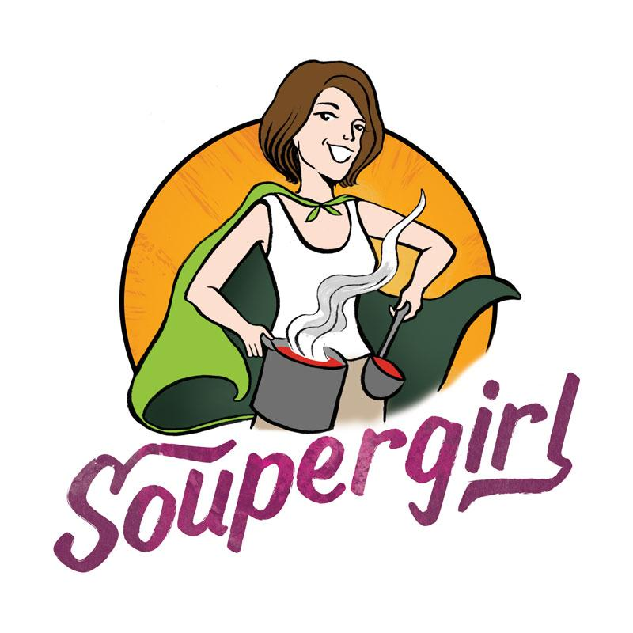

Silver Spring Takoma Park Restaurant Week Menu

$12.00

Combo Includes: 1 Small Soup
1 Small Salad
Bread Roll or Cookie
Drink

*All diners will have the option to be entered into a Soupscription drawing! Winners will receive 4 pints of soup delivered to their homes once a week for a month.

