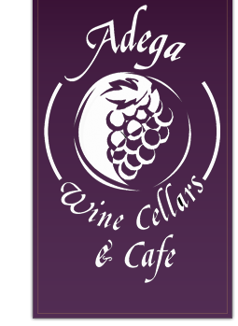

Silver Spring Takoma Park Restaurant Week 2016 Menu
Dinner for 2 - $45
1 appetizer
2 entrees
1 bottle of wine under $20
1 dessert

