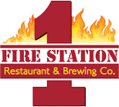

**Silver Spring Takoma Park Restaurant Week**

Lunch 2-Course $12

Appetizer:

Station Cheese Nachos

Mozzarella Sticks

Station Wedge Fries

Entrée:

French Dip

Rueben

Grilled Mahi Wrap

Dinner 3-course $24.99

Appetizer:

Spinach Artichoke Dip

Station Wings

Station Pot Stickers

Entrée:

(served with Mashed Potato & Veggie of Day)

Grilled Salmon Platter

Bourbon BBQ Chicken

Chicken New Orleans

Dessert:

Station Bread Pudding

Brownie with Ice Cream on Top