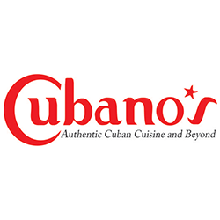
SILVER SPRING TAKOMA PARK RESTAURANT WEEK 2016

2-Course Lunch Special ..........$12.00

1-Choice of: Soup or side salad.

2-Daily Special or Cuban Sandwich.

.............................................................................

3-Course Lunch Special..........$17

1-Choice of: Soup or side salad.

2 – Lunch Appetizer.

3-Daily Special.

