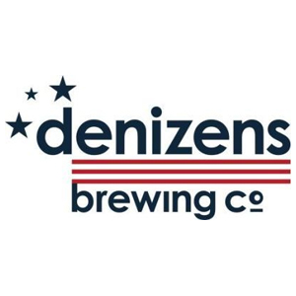
Silver Spring Takoma Park Restaurant Week 2016

$17 for 2 Courses, $27 for 3 Courses

Available at Dinner only Tuesday-Friday and All Day Saturday and Sunday

Course 1 (pick one)
Pretzel
warm pretzel and lowest lord esb cheese dip

Crispy Brussel Sprouts
with avocado mousse, heirloom beans, and red beets

Course 2 (pick one)
with fries or garden salad

Kitchen Burger
brisket, pickled onions, goat cheese, arugula, and tomato jam

Tomato Basil Toast
cherry tomatoes, pesto, mozzarella, and balsamic reduction

Course 3 (if selecting three course option - pick one)
Fried Dough
chai spice and dulce de leche

Stuffed Pastry
pastry, macaroon, orange marmalade, lemon curd, and whipped cream

