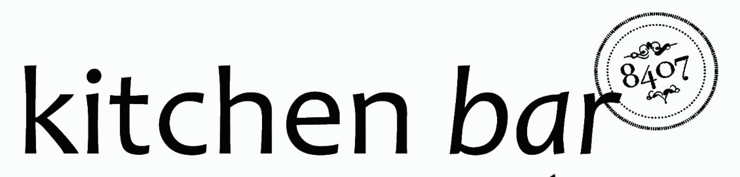

Silver Spring Takoma Park Restaurant Week 2016

Business Lunch - $12
Available 11:30am-2:30pm Daily

Any Draft Beer, House Wine or non-alcoholic beverage
&
Any Burger, Sandwich* or order of Tacos

*excluding the Maryland Crab Cake Sandwich

